**Internet Explorer - Clear Browser Cache (completely)**

Steps:

----------

How to completely clear you’re IE Browser Cache:

* Close all instances of IE that is running
* Launch IE and go to Tools-Internet Options



* Within Browsing History, click Delete
  + Select everything except for ‘Preserve Favorites website data’. Click Delete

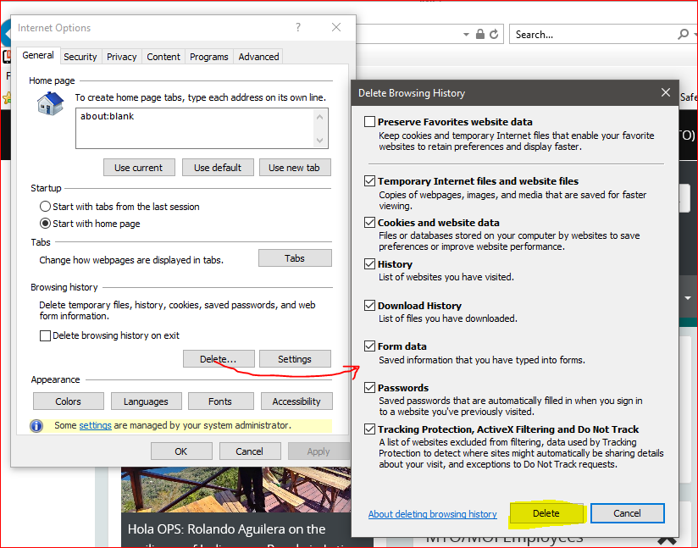

* + Wait a few seconds until the cursor stops spinning
  + Now click Settings
  + In the Website Data Settings, click View Files…  This will open windows explorer to your Temporary internet Files folder

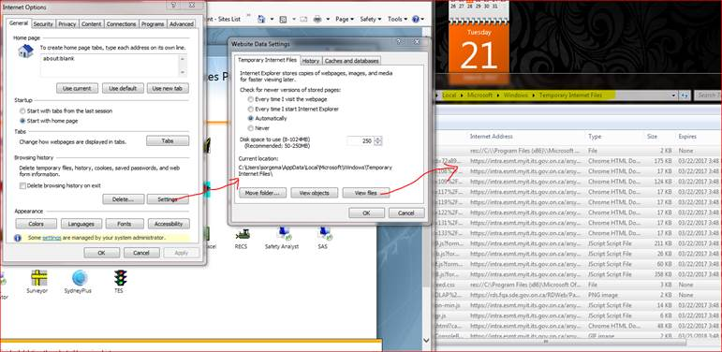

* + Select All the files within the Temporary Internet files folder and Delete all of them
    - If this folder is empty, that is expected if you unselected ‘Preserve Favourites website data’ option.
  + Close all the windows and Close IE

----------

**Google Chrome - Clear Browser Cache (completely)**

Steps:

----------

How to completely clear you’re Google Chrome Browser Cache:

* Close all instances of Chrome that is running
* Launch Chrome Browser and over to the right of the address box click the vertical Ellipsis…



* Select History-History

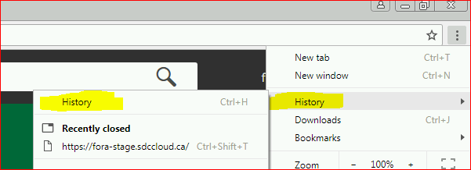

* Within Browsing History, click ‘Clear browsing data’. This will bring up the Clear browsing data window…
  + Select the Advanced Tab
  + In the Time range drop down box, select ‘All time’
  + Select every check box option that it offers

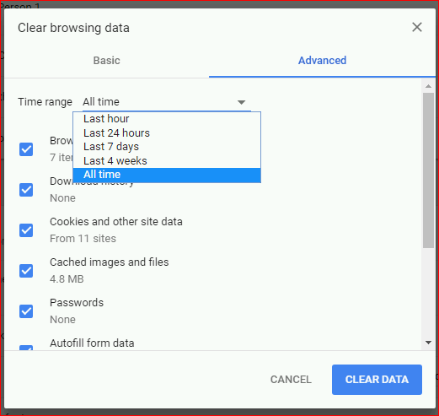

* + Click CLEAR DATA
  + Wait for it to finish
  + Close the Chrome Browser

----------

**Edge - Clear Browser Cache (completely)**

Steps:

----------

How to completely clear you’re Edge Browser Cache:

* Close all instances of Edge that is running
* Launch Chrome Browser and over to the right of the address box click the horizontal Ellipsis…



* Select History

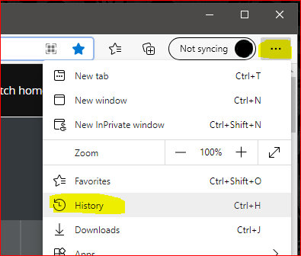

* With the History list open, Click the horizontal Ellipsis
  + Select ‘Clear browser data’

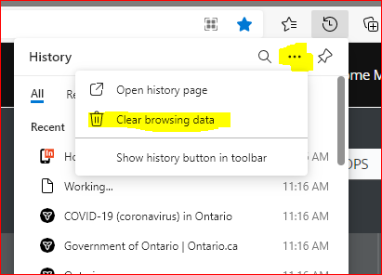

* The Clear browsing data box should appear…
  + In the Time range drop down box, select ‘All time’
  + Select every check box option that it offers

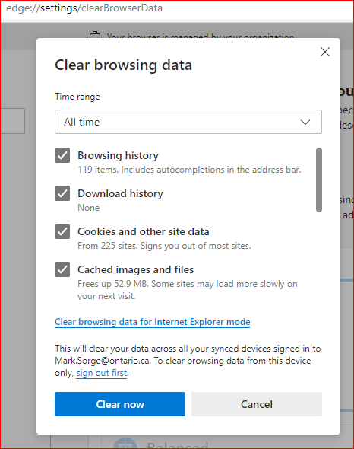

* + Click ‘Clear now’
  + Wait for it to finish
  + Close the Edge Browser

----------